Query Jennifer

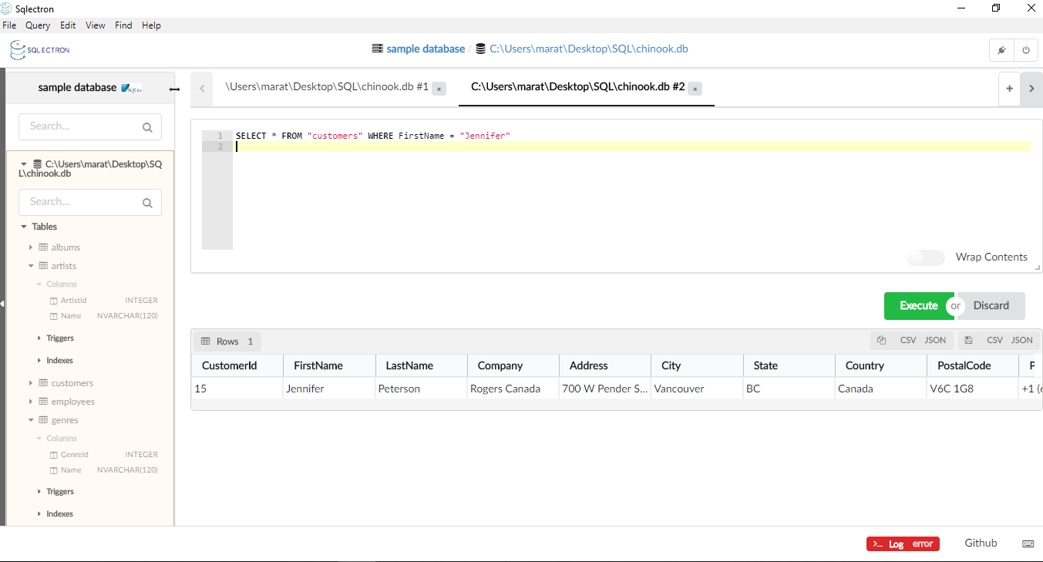

Query Name and Composer

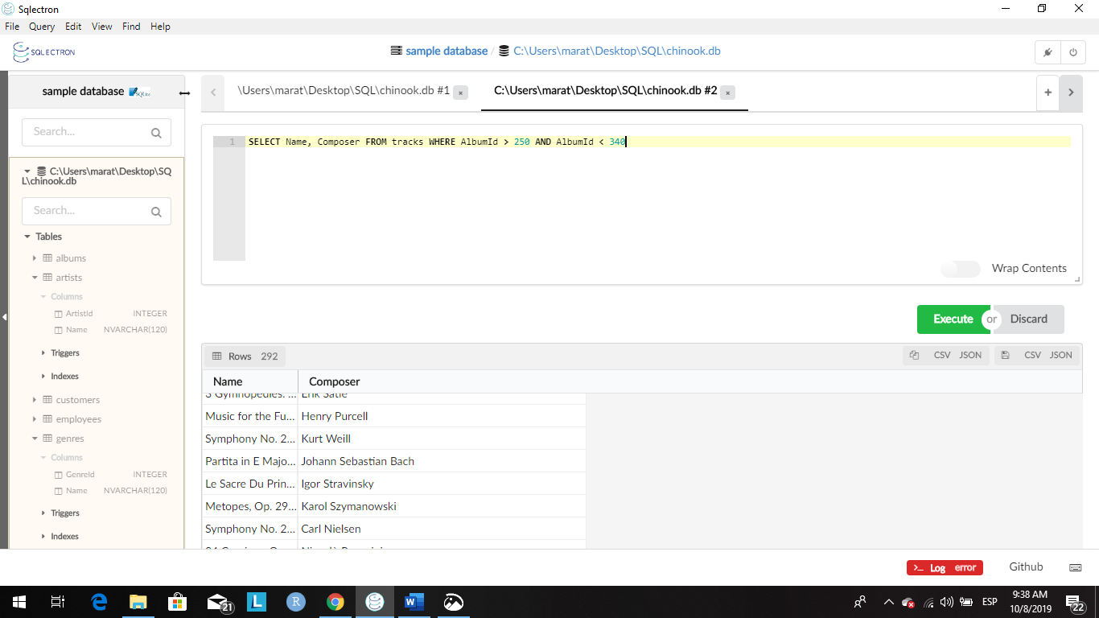

Brazilian customers

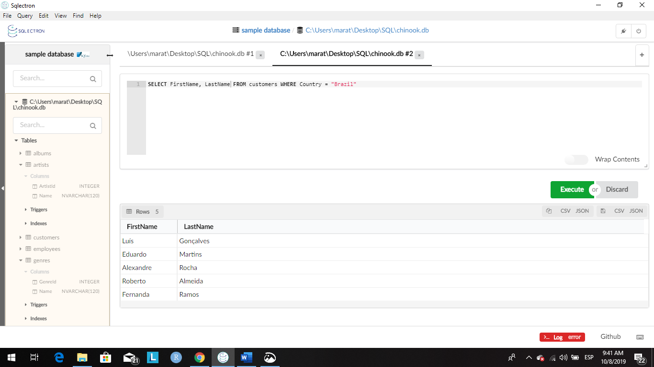

Answer in the website

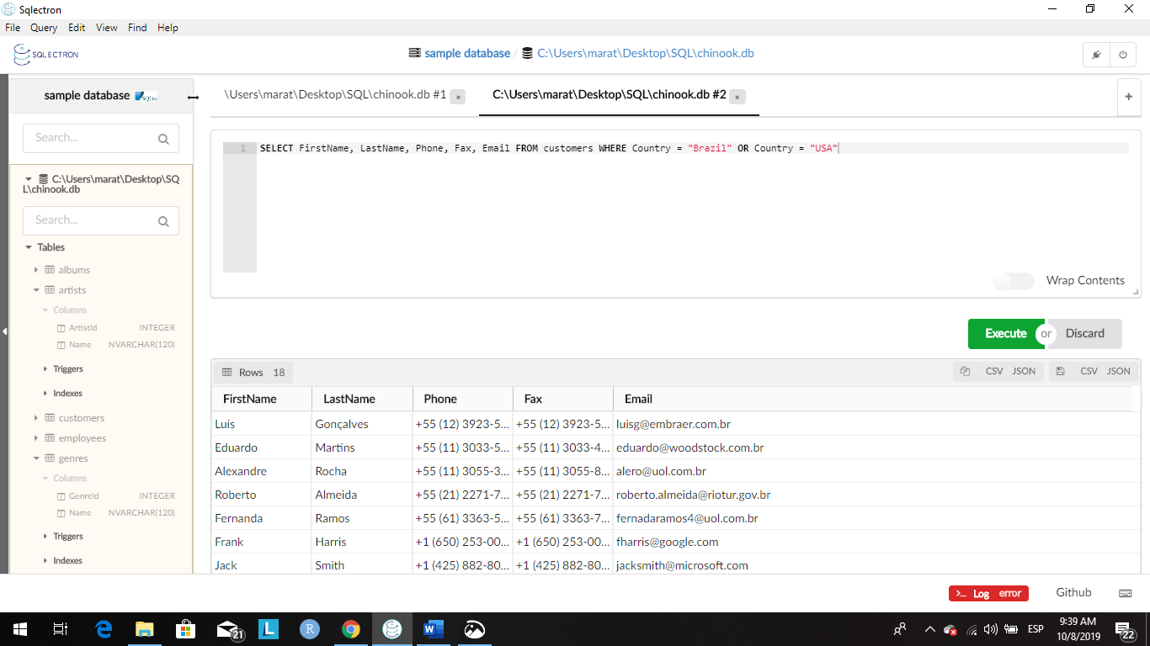

All columns of the albums with a title that begin with an “a”

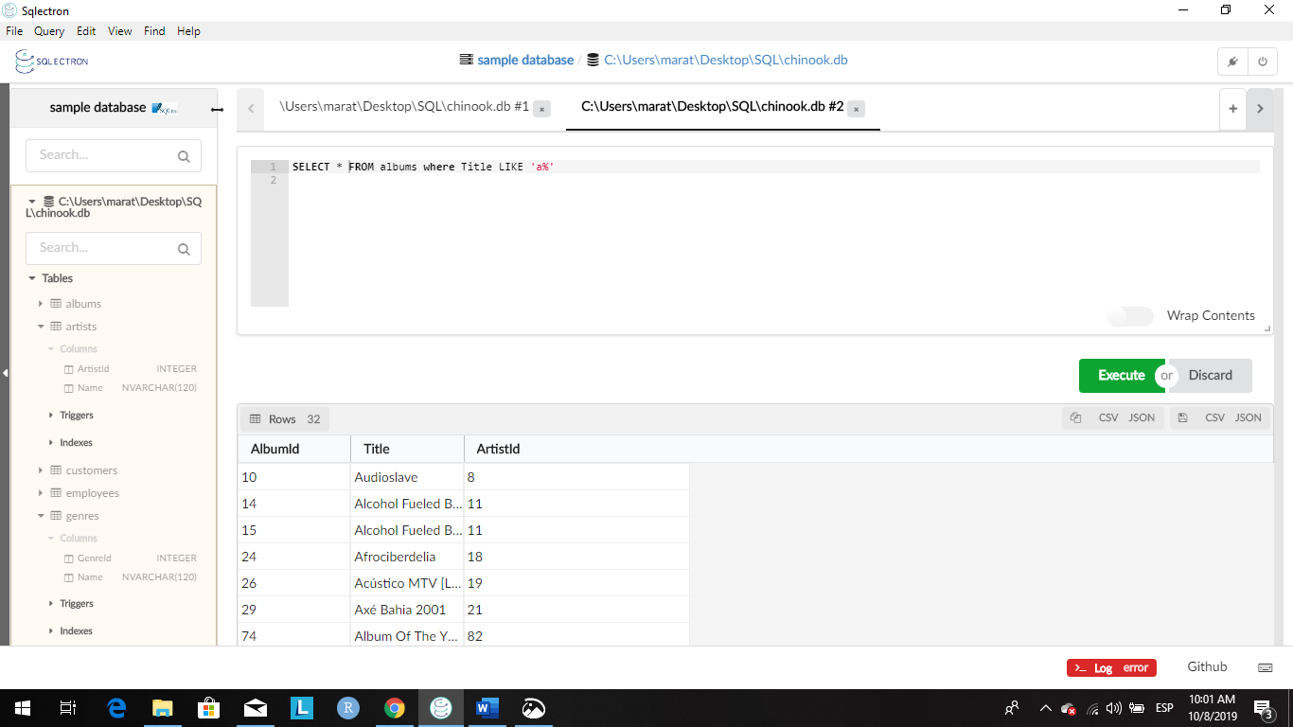

¨Playlists

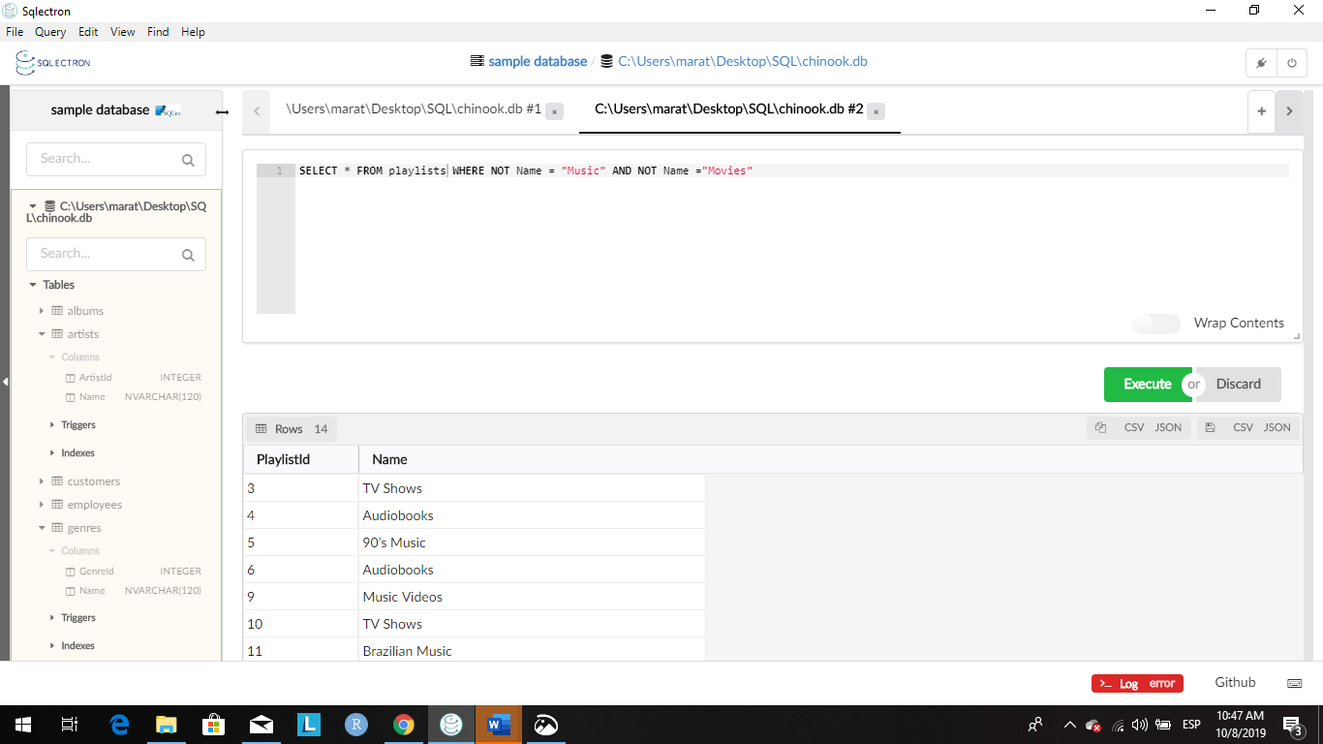

Name, Composer, Bytes

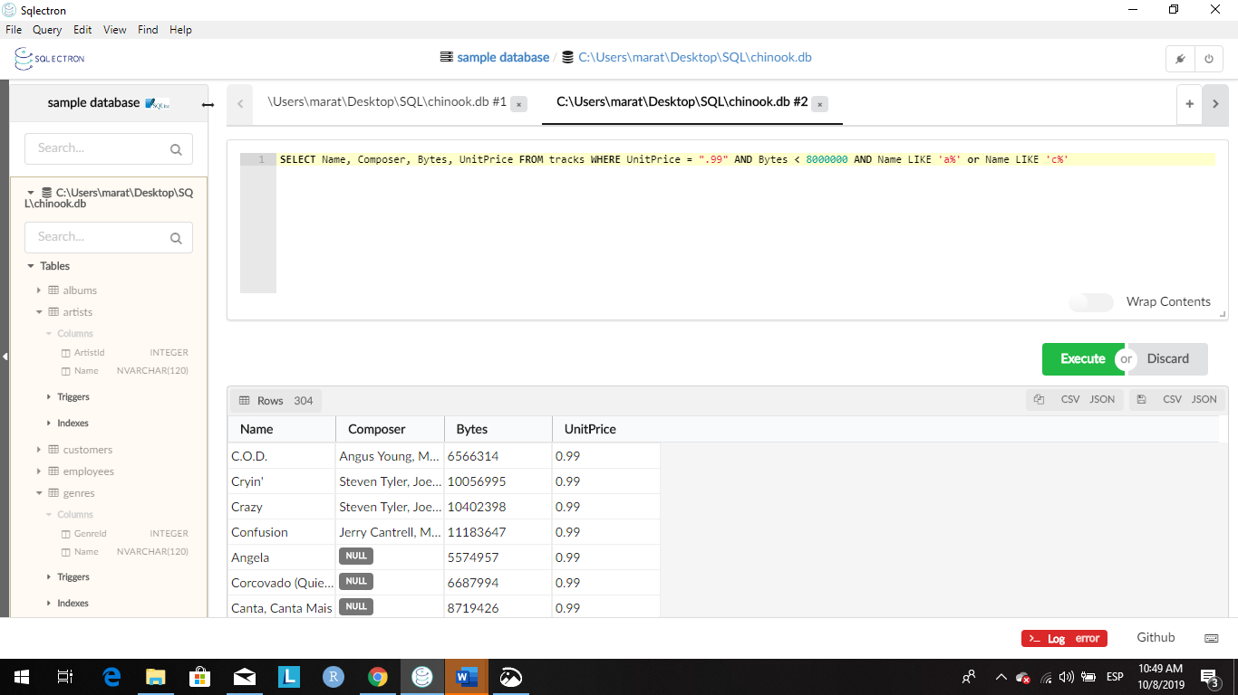

You were just hired at a company as a data analyst, and your company needs some information from the database. They would like to see all tracks that have a Unit Price over .99 cents. However, they only want to see the Name and any Id that is attached to that track. Once you have finished that, they would like to see the Invoice Id and Track Id of the invoice items that have a UnitPrice over .99 cents.

Query1

